**Ideation Phase**

**Brainstorm & Idea Prioritization Template**

|  |  |
| --- | --- |
| Date | 20 September 2022 |
| Team ID | PNT2022TMID37477 |
| Project Name | Smart Fashion Recommender Application |
| Maximum Marks | 4 Marks |

***Brainstorm & Idea Prioritization*:**

**Step-1: Team Gathering, Collaboration and Select the Problem Statement**

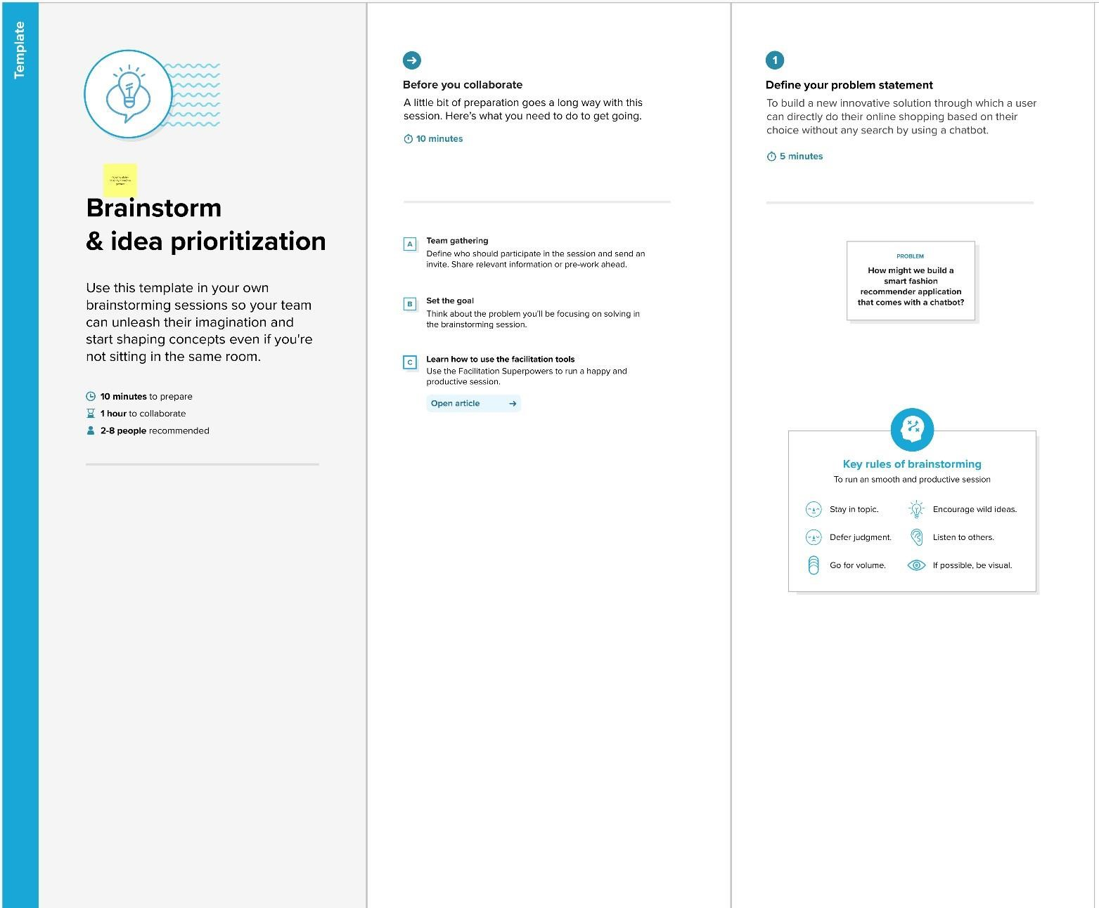

***Step-2: Brainstorm, Idea Listing and Grouping***

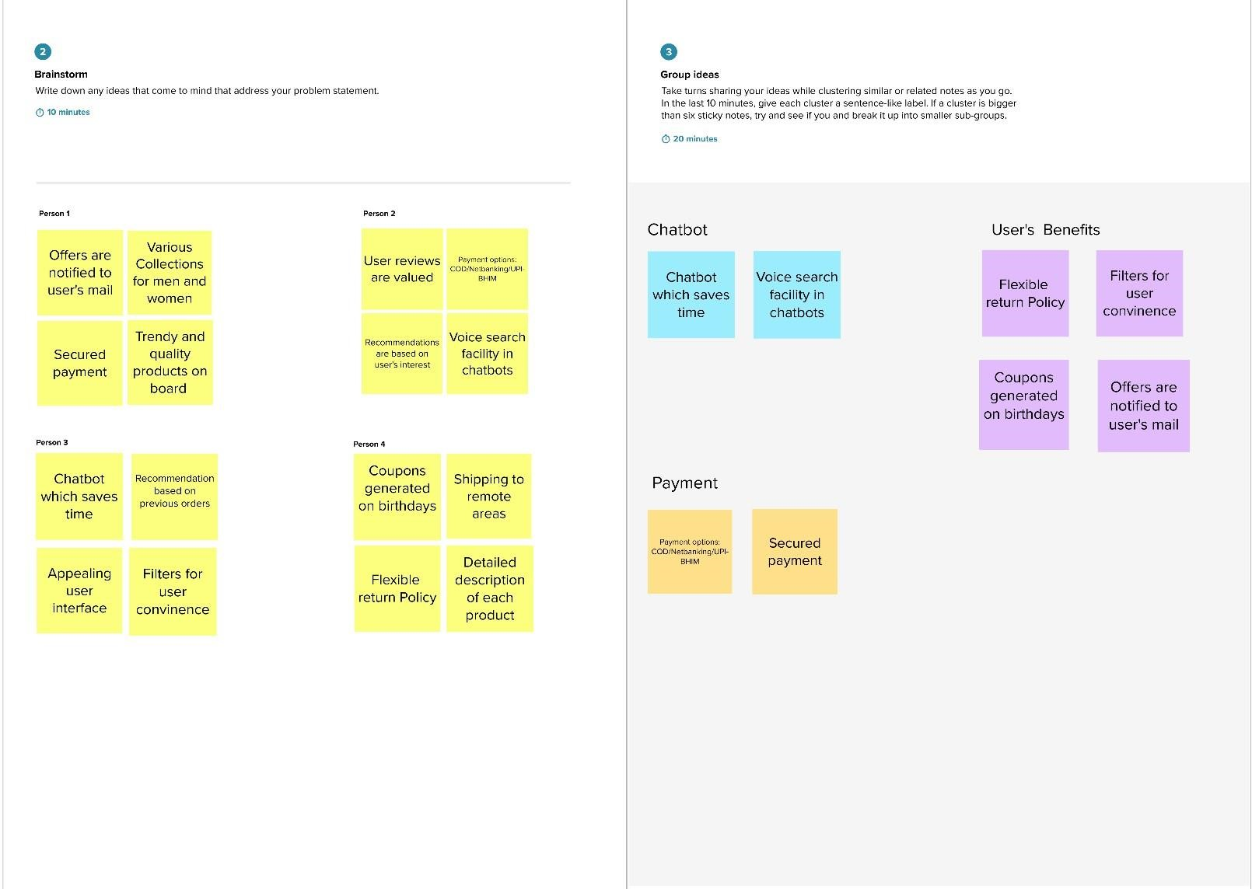

***Step-3: Idea Prioritization***

